The US

1. INTRODUCTION

**SPEAKING PRACTICE**

What do you know about the United States of America?   
What are the most famous stereotypes about Americans?   
Do you agree with the following pictures?

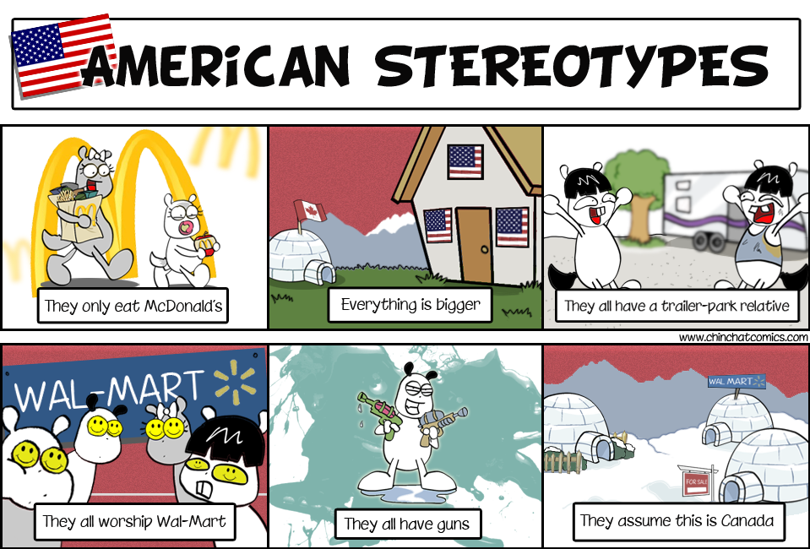

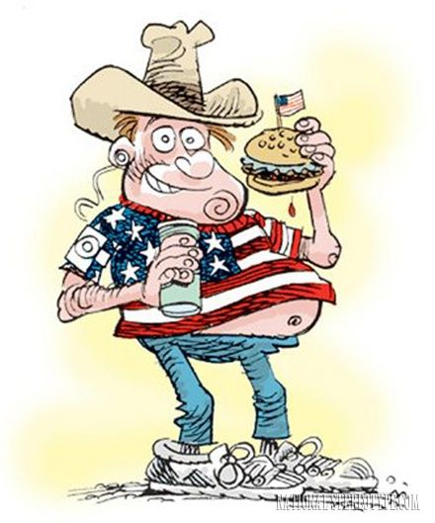 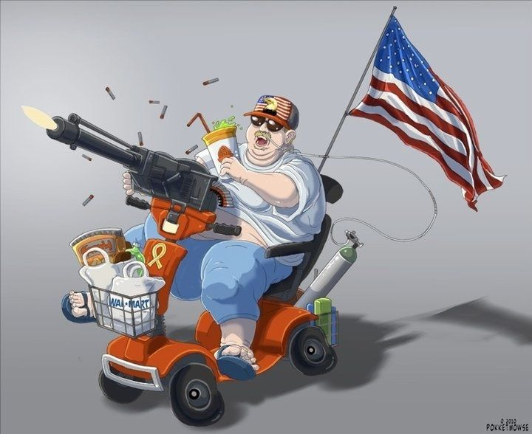

**WARMER**

|  |  |  |
| --- | --- | --- |
| The USA is made up of **(1)** states and a federal district (District of Columbia). Two states, **(2)** and **(3)**, are not directly attached to the continental US. It is the **(4)** most populated country in the world , with more than **(5)** inhabitants. The main spoken language in the United States is **(6)** but in many areas **(7)** is spoken . | 1578638362034_usa-flag-std.jpg | |
| **(1)** | | **(5)** |
| **(2)** | | **(6)** |
| **(3)** | | **(7)** |
| **(4)** | |  |

* + - 1. How many horizontal stripes and stars are there on the Flag of the USA? According to you what do they represent?

**50 states**

* + - 1. The Flag of the United States goes by different names. Which ones?

“The stars and stripes, Old Glory, Star-Spangled Banner

* + - 1. People from the USA are called…American………………………………………. .

Match the following states in the pictures to the definitions.

|  |  |  |
| --- | --- | --- |
| alaska.jpg | 3248802_0.jpg | state-hawaii-5067845.jpg |
| 41GB7oImy3L._AC_SS350_.jpg |  | Louisiana-State-Heart-Sticker.png |

1. …Florida………….. is nicknamed “the Sunshine State” and is known for the spacecraft launchings from Cape Canaveral.

2. California……….. is the most populous state with the famous cities San Francisco and Los Angeles ; it is also known for its desert valley called the Death Valley.

3. Alaska……….. is the largest state and has the longer coastline in the US and it doesn’t border with the rest of the states.

4. Louisiana……….. is a state located in the southern region with the largest city New Orleans of which 80% was flooded by Hurricane Katrina in 2005.

5. Hawaii………….. is the only US state located in Oceania and made up entirely of islands with the capital Honolulu.

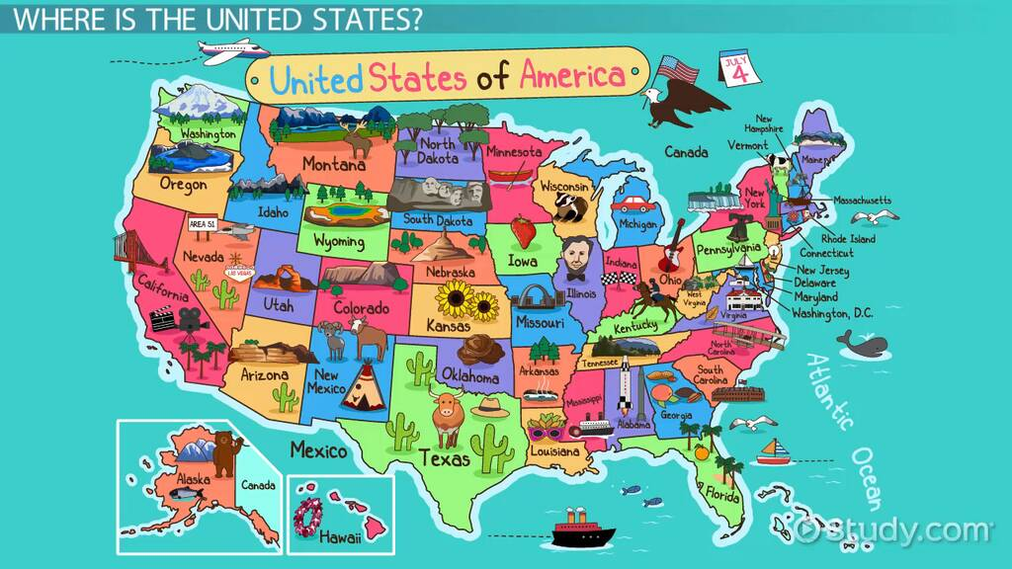

GAME: https://online.seterra.com/en/vgp/3003

1. LANGUAGE

**SPEAKING ACTIVITY**

What do you know about the history of the US?   
Do you know some famous events? Famous people?

**LISTENING ACTIVITY**

<https://www.youtube.com/watch?time_continue=41&v=kquAIJg8vRE&feature=emb_title>

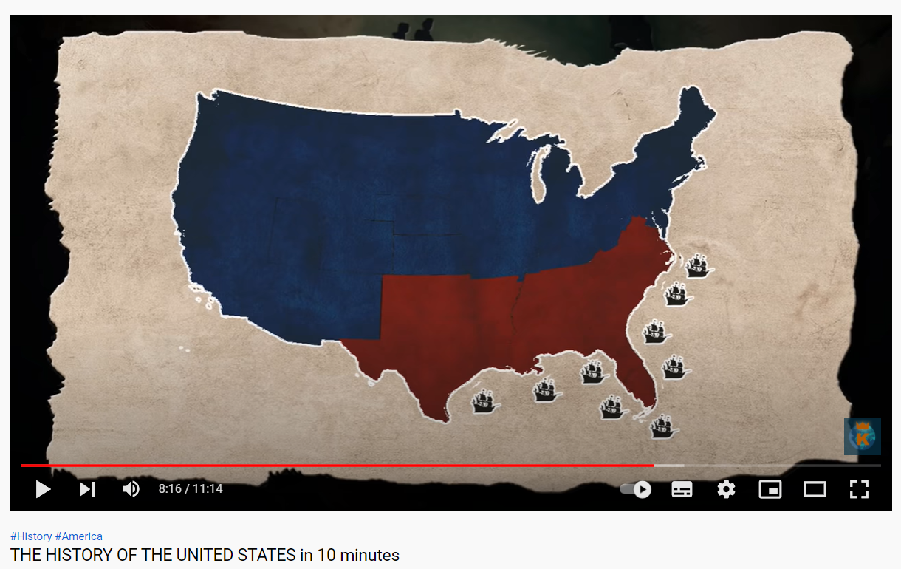

1. What are the important dates of the Independence of the US?

1. What is it said about the first native americans?
2. 2’: What were they called?

paleoamericans

1. What happened in the 15th century?

European colonisation began

1. What was the goal of Columbus?

Find a new trade route to the far east

1. Where did they land & set up their empire?

The new world

1. What can we say about the French colonization?

The founded colonies in eastern north america

1. What about the UK?

The colonised the eastern sea cost

1. How many colonies were there in the late 17th?

1. What was a colony?
2. What did attract many more immigrants, & in particular African slaves?

Low death rates

1. Why did America need Britain?

They needed military support

1. When did France lose their colonies?

During the seven year war

1. Which event was the start of the Revolution?

Political developpment

1. What did the new states of America suggest to France?

1. Name 2 men who played a role in the Independence

George Washington, Thomas Jefferson

1. What were the origins of the American Civil war?

Taxes, and dindependance

***To know more****: https://www.youtube.com/watch?v=T9Sc0VrLpzk&t=31s*

**SPEAKING ACTIVITY**

According to you, what are the most spoken languages in the US? Why?   
What are the potential phenomena that could have influenced the country?

**READING ACTIVITY**

<https://www.worldatlas.com/articles/the-most-spoken-languages-in-america.html>

The Most Spoken Languages In America

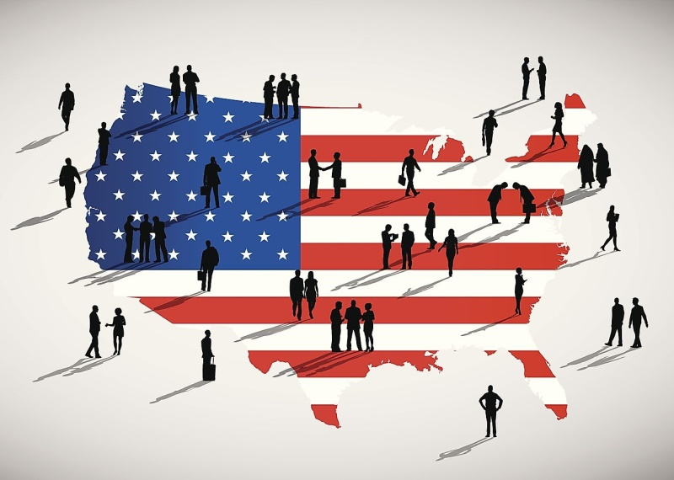

The United States is a leader in international business and a country based on immigration, resulting in a dynamic country wherein English is the most widely spoken language but where French, Arabic, and Bengali all have many speakers as well.

1. **A Country Of Immigrants**

Immigration has largely influenced the demographic patterns of the United States. The predominant majority of US immigrants hail from neighboring [**Mexico**](https://www.worldatlas.com/maps/mexico) and other Latin American countries. A large influx of Hispanic people has made Spanish the second most widely spoken language in the country. In California and Texas, the Spanish language is spoken and understood to some degree by over 20% of the population. Other states where Spanish’s influence can be greatly felt are New York and Florida. In the latter case, the state's proximity to Cuba and the high rates of immigration from the Caribbean countries have increased the popularity of Spanish in the state.

Technology also has a direct influence on the frequency and variety of languages spoken in the [**United States**](https://www.worldatlas.com/maps/united-states). Technology companies, in a bid to keep up with a high level of global competition, have been forced to employ workers from other technology dominant nations. Most of these expatriates are from Asian countries where technology has been at the forefront of economic development for decades. These immigrant workers have added to the linguistic diversity of the US. Mandarin Chinese is the most widely spoken Asian language in the country. Nearly 2% of the American population can communicate in this language. Besides Chinese, other Asian languages commonly spoken in the US include Korean, Tagalog, and Vietnamese.

1. **German And Jewish Influences**

German and Hebrew are also spoken in the US by a significant proportion of the population. German immigrants have been arriving in the area since the colonization of the New World. German-Americans is one of the largest ethnic groups in the country. The German influence in the United States can be heavily felt in places such as Chicago, South Dakota, and North Dakota. Hebrew is also commonly spoken in the country since the US has the highest Jewish population outside [**Israel**](https://www.worldatlas.com/maps/israel). The United States and Israel share very close political and economic ties, and this has contributed to a large influx of Israelis into the country. Many Jews also immigrated to the US from Europe to escape the Holocaust. Los Angeles and New York City are great examples of American cities with large Jewish populations today.

1. **The Absence Of Native American Languages**

Without a doubt, the United States is a highly multicultural country. It has received immigrants from all across the world who have contributed to the linguistic diversity of the nation. However, one must not forget the indigenous languages of the native Americans that are at great threat today. It is important to note that no native American language makes it to the list of the top 25 languages spoken in the US. The Navajo language, which is the most widely spoken Native American language, has roughly 170,000 speakers only. Thus, the state of preservation and growth of Native American languages is a major issue in the country.

VOCABULARY

Explain the following words:

* Demographic patterns – tendance demographique
* Hail from neighboring – provenir du voisinage
* Influx - flux
* Latter – plus tard
* In a bid to – dans le but de
* To keep up - entretenir
* Expatriates - expatriés
* To be at the forefront – être au premier plan
* Besides – en outre
* Heavily felt – fortement ressenti
* Ties - liens
* Without a doubt – sans aucun doute
* To be at great threat – être très menacé
* Roughly – environ

1. **Most US Native Speakers By Language**

Try to find the top 10:

| **Rank** | **Primary Language Spoken at Home in the US** | **Number of speakers** |
| --- | --- | --- |
| 1 |  | 231,122,908 |
| 2 |  | 37,458,470 |
| 3 |  | 2,896,766 |
| 4 |  | 2,047,467 |
| 5 |  | 1,613,346 |
| 6 |  | 1,399,936 |
| 7 |  | 1,117,343 |
| 8 |  | 1,063,773 |
| 9 |  | 924,374 |
| 10 |  | 879,434 |

1. VALUES

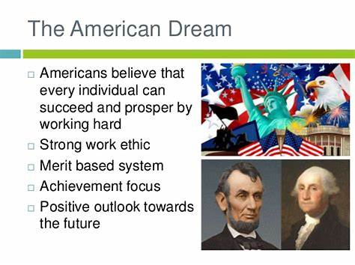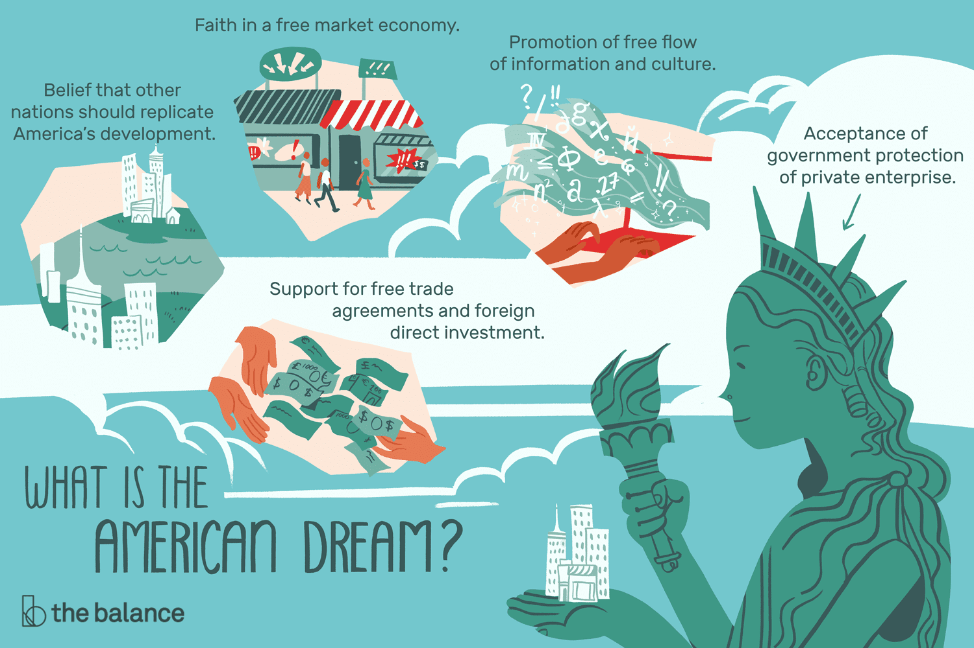

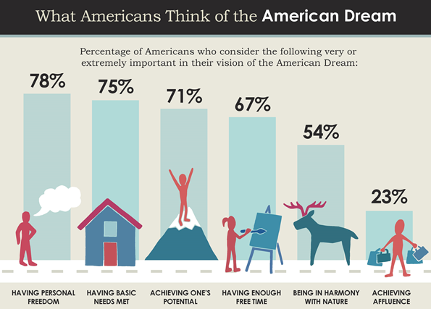

**LISTENING ACTIVITY**

<https://www.youtube.com/watch?v=pHVksFyfBks>

1. Name all the Founding Fathers



1. Why were they called “Founding Fathers”?

1. Who are “Founding Mothers”?



**READING ACTIVITY**

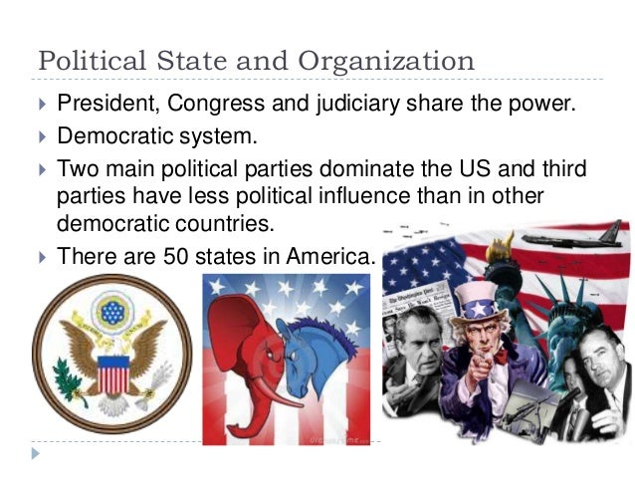

[Meaning behind the political party mascots - YouTube](https://www.youtube.com/watch?v=tqnwC_LyFxo&t=40s)

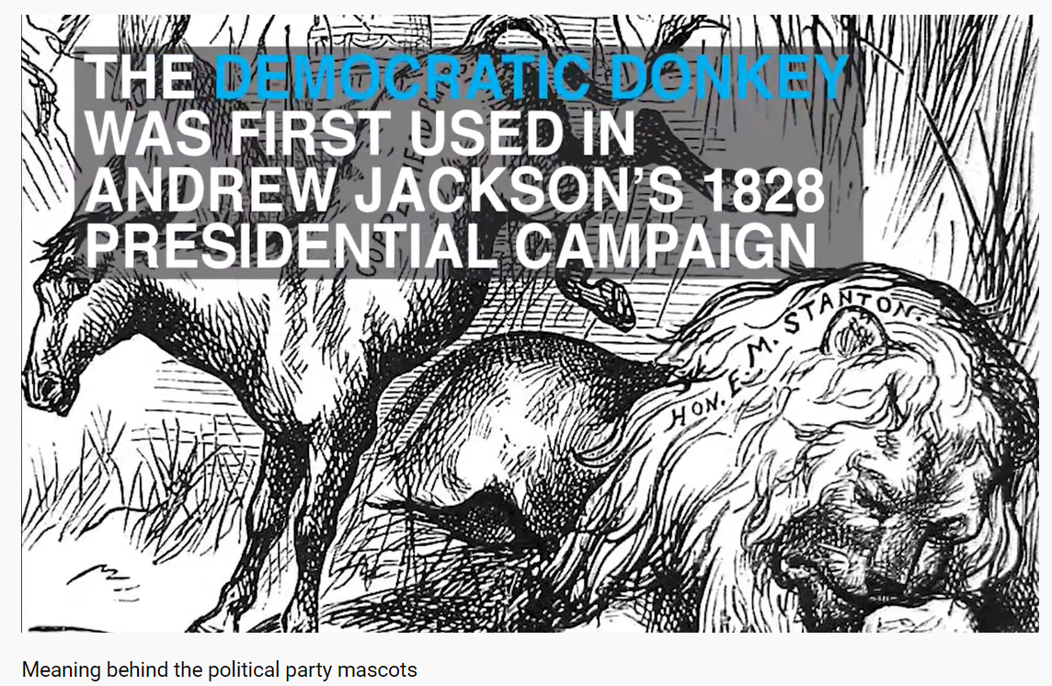

Give details about each symbol

|  |  |
| --- | --- |
| DEMOCRATIC PARTY | REPUBLICAN PARTY |
|  |  |
|  |  |

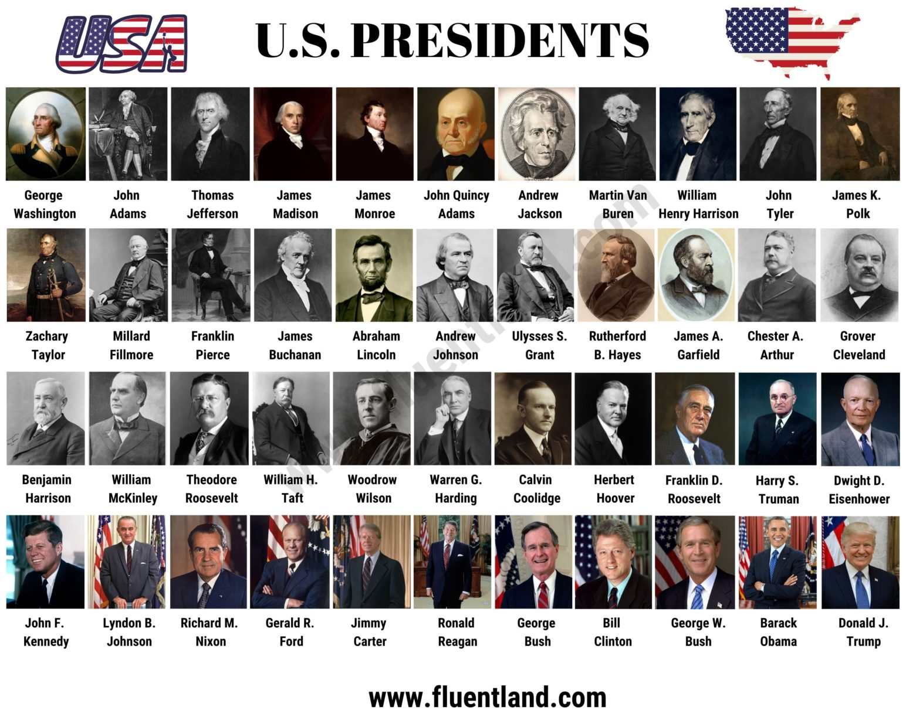

**SPEAKING ACTIVITY**

What do you know about JFK’s murder?   
What are the possible theories?   
What is your hypothesis?

**LISTENING ACTIVITY**

<https://www.youtube.com/watch?v=TGPsiaXIf40>

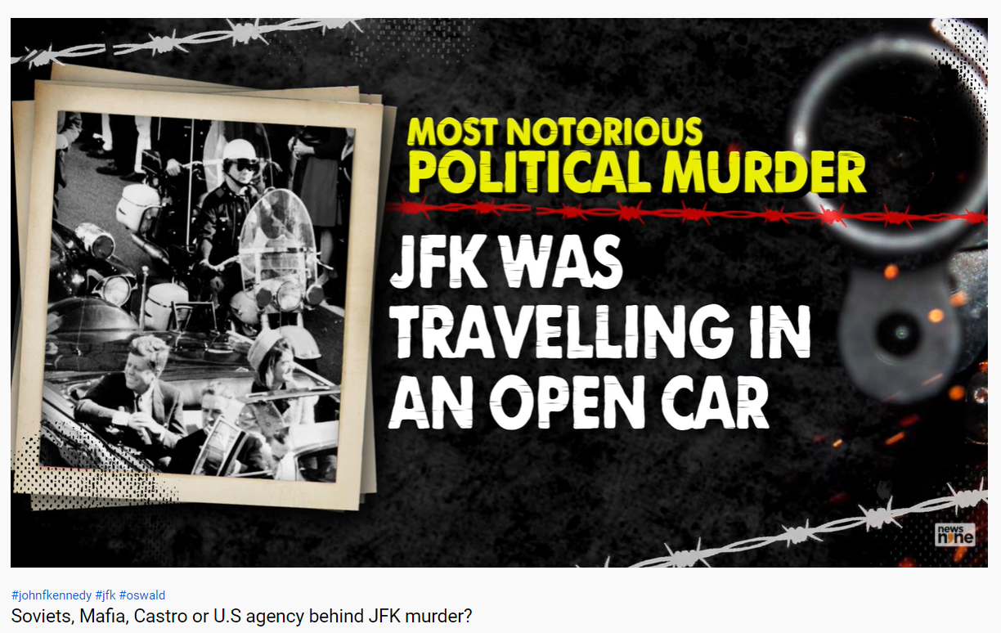

What are the consipracy theories about JFK’s murder?

Match the beginnings with their endings to create correct phrases

|  |  |
| --- | --- |
| High-profile | By two shots |
| Favourite | a tsunami |
| To add fuel to fire | The plot |
| Released documents | on JFK murder probe |
| To open up | Of Soviet Union |
| Intricate | Child |
| Struck | Muder mystery |
| Held | for kennedy’s murder |
| To spark | Details |
| On behalf | A pandora’s box |
| To hatch | To fire |

1. BELIEFS

**READING ACTIVITY**

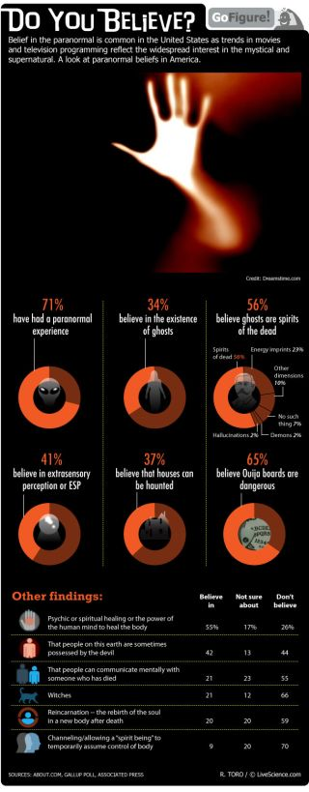

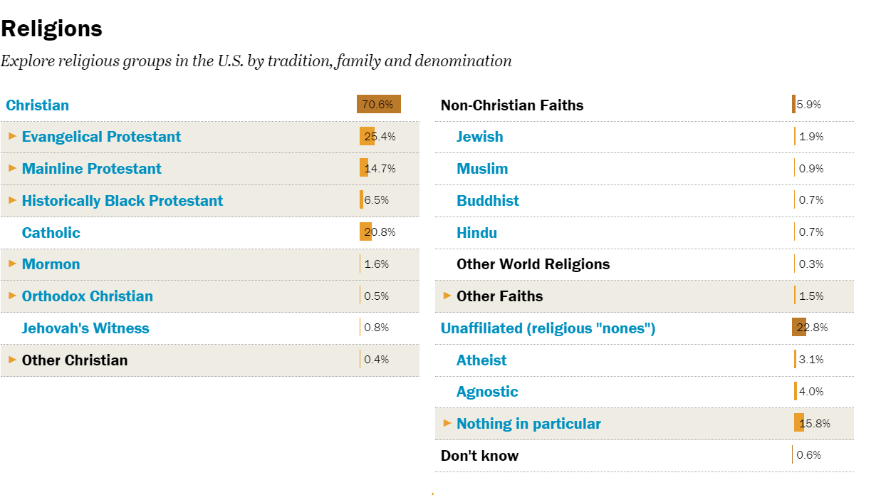

**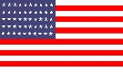READING ACTIVITY**

**Place the Federal Holidays’ names in the circle and add the exact day.**   
Christmas Day – Washington’s Birthday – Labor Day – Juneteenth - Veterans Day – New Year’s Day – Thanksgiving Day – Independence Day – Martin Luther King Day – Columbus Day – Memorial Day

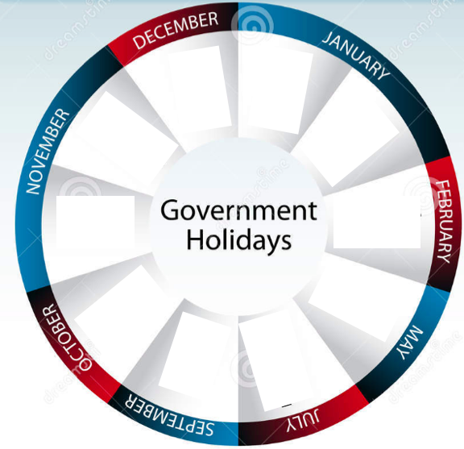

Among those bank holidays, **a new one was born in 2021**. Which one is it, do you think?

Officially called ……………………… National Independence Day and also known as Jubilee Day, Emancipation Day, Freedom Day, and Black Independence Day, it is**a federal holiday in the United States commemorating the emancipation of African-American slaves.** It is also often observed for celebrating African-American culture. Originating in Galveston, Texas, it has been celebrated annually on June 19 in various parts of the United States since 1865. The day was recognized as a federal holiday on June 17, 2021, when President Joe Biden signed the Juneteenth National Independence Day Act into law. Juneteenth's commemoration is on the anniversary date of the June 19, 1865, announcement of General Order No. 3 by Union Army general Gordon Granger, proclaiming freedom for slaves in Texas, which was the last state of the Confederacy with institutional slavery.

**Thanksgiving**

**Vocabulary: match the following words with their definition.**

|  |  |  |
| --- | --- | --- |
| 1. To mark |  | 1. fresh, refreshing |
| 1. winter solstice |  | 1. to extend, to reach over |
| 1. a retailer |  | 1. a lot of |
| 1. to a large extent |  | 1. to eat as much as possible, to overeat |
| 1. a feast |  | 1. to make bigger, better or more complete. |
| 1. to round out |  | 1. the shortest day of the year, which usually occurs on Dec 21 or 22. |
| 1. to stuff oneself |  | 1. a festive celebration or entertainment. |
| 1. a pilgrim |  | 1. to a large amount, degree |
| 1. a plethora |  | 1. a large and high-quality meal usually with entertainment for several people |
| 1. a fete |  | 1. to show |
| 1. crisp |  | 1. a person or corporation that sells goods |
| 1. to span |  | 1. a person who travels, especially a long distance, to some foreign place. |

**Before watching the video, guess if the following statements are true or false. If they are false, try to justify. Then compare it to the group and let’s guess who is right.**

|  |  |
| --- | --- |
| Thanksgiving is a British celebration and a public holiday. | True - False |
| It takes place the last Friday of October. | True - False |
| The traditional main course is pork. | True - False |
| The Thanksgiving meal of today is rooted in the meal that the pilgrims from Europe shared with the native Americans on the first Thanksgiving. | True - False |
| Thanksgiving is a very good opportunity for retailers. | True – False |
| At the beginning, Thanksgiving lasted a whole week. | True - False |
| On that day, it is tradition to prepare the meal watching football on TV. | True - False |
| Thanksgiving is only celebrated in the USA. | True – False |
| Thanksgiving became a national holiday in 1776, thanks to Georges Washington. | True – False |

**Then watch the video to check your answers:**[*https://www.youtube.com/watch?v=uG4XyNqUQxg*](https://www.youtube.com/watch?v=uG4XyNqUQxg)

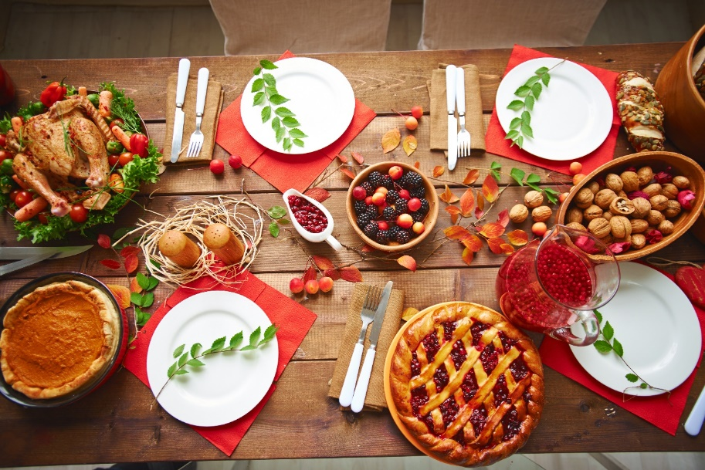

**SPEAKING PRACTICE**

What are the other traditions that you know?   
What do they do?   
Could you compare them to some ours?

1. NORMS

**SPEAKING PRACTICE**

What are the do’s & don’ts in the US?   
Have you ever experienced a bad situation because of some misunderstanding?   
What are the norms that you know?   
And what about business? What are the rules when dealing with American counterparts?

**READING ACTIVITY**

<https://harrisburg.psu.edu/international-student-support-services/guide-american-culture-etiquette#:~:text=%20Guide%20to%20American%20Culture%20and%20Etiquette%20,eat%20quietly%20with%20their%20mouths%20closed.%20More%20?msclkid=da552b2aa5e111ecb1edb2743ad7aff1>

**Guide to American Culture and Etiquette**

Alcohol/Smoking/Drugs

* Drinking under the age of 21 is illegal.

Animals and Pets

* Americans tend to love their pets and see them as “part of the family”.
* The most popular pets in the U.S. are dogs, cats, hamsters, and fish.

Classroom Etiquette

* The relationship between professors and students is more like friendship.
* Students remain seated when the professor arrives or when the student’s name is called.

Dress and Modesty Standards

* Students tend to dress casually during the daytime at school.
* Most Americans have no problem shopping in their sweatpants!

Driving Laws and Etiquette

* Honking your horn means a lot in America and can make drivers angry if it seems unnecessary. Limit how often you honk your horn.
* It is important to have cash with you when driving to pay for tolls that are required. Credit cards are not acceptable.
* In the States, you must STOP at least 10 feet away from a school bus when you see it stopped with its lights on or its sign extended.
* People here prefer long distance driving rather than taking a train or flight.

Eating Culture and Etiquette

* Americans like sweets! Burgers, sandwiches, and pizza are eaten with hands, instead of utensils.
* Americans tend to value convenience when it comes to food. They don’t spend as much time cooking and savoring their food. The pace of life has lent itself to the success of fast food restaurants, convenience stores, pizza delivery, and “carry out” options.
* Most Americans eat three times a day. Cold cereal with milk is common. However, toast, fruit, bagels, yogurt, and eggs are common breakfast options too.
* People in U.S. usually eat a light lunch and typically eat it “on-the-go”. Lunch possibilities include soup, sandwiches, or a salad. This is normally eaten between 12 and 2pm. The evening meal is the largest of the three meals and is typically eaten between 5:30pm and 7:00pm. This meal is called “supper” or “dinner”. Common meals include meat or fish and vegetables, pasta, or pizza.

Gestures

* While potentially offensive in many cultures, giving the “thumbs up” can mean, “Good!”, “That’s cool!”, “Congratulations!”, or “Good job!” in the USA.
* Pointing at people is seen as rude.
* American people often frown their faces when they say "no" or "I don't know" or " excuse me?" in any normal conversation.
* In American culture, people move one or two fingers with their palms up when they want to say "come here," and move four fingers together with turning the palm down when they want to say "go away".

Getting in Line

* In the U.S., people get in line and wait for their turn when buying tickets, shopping, using the restroom, or waiting for a bus, etc. It is considered rude to cut in line or push your way through.

Restaurant Etiquette

* Tipping your server 15%-20% is required. No tips are needed at fast food restaurants or for “carry out”.
* “Doggie bags” are a common way to package leftovers and take them home.

Social Courtesies

* Smiles are basic signals of politeness, a non-verbal way of being friendly.
* “Small talk” is acceptable & is considered “nice”.
* Americans like their personal space and stand about 2 feet apart when talking. Physical touching when in a conversation usually makes Americans uncomfortable.
* Most people shake hands firmly and briefly when they meet for the first time or in a formal situation.

Usage of First Name, Last Name, and Title

* Most Americans, even in a business setting, will prefer to be called by their first name. However, it is good principle to address them by their title (Mr., Mrs., Ms., Dr., or Professor) and last name unless you are invited to do otherwise.
* Americans may call you by your first name once they’re introduced to you. This is not considered rude, but may reflect a casual style.
* In general, it is polite to initially call a woman Miss (Ms.) until you’re invited to do otherwise.
* Using “Sir” and “Madam” are not common

1. ARTEFACTS

**SPEAKING ACTIVITY**

What is your favourite American meal? Why?   
What other typical meals do you know?   
What could you say about American food?

**READING ACTIVITY**

https://www.traveller.com.au/the-traveller-10-musttry-american-food-gqbjjm?msclkid=80ee7a30ae8311ecb81e5697ed515461

***Best traditional USA dishes: Top 10 must-try American foods***

**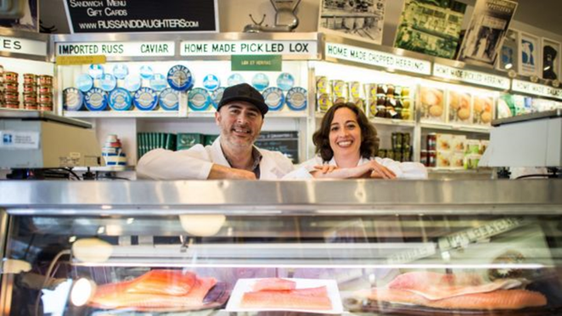***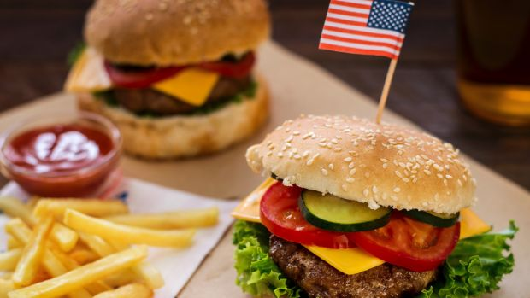***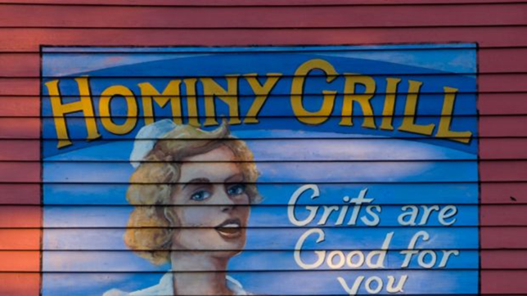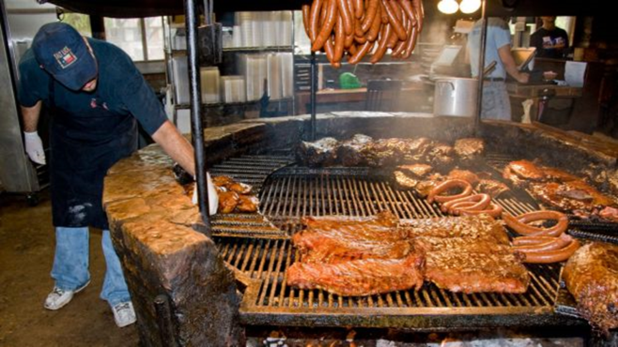** *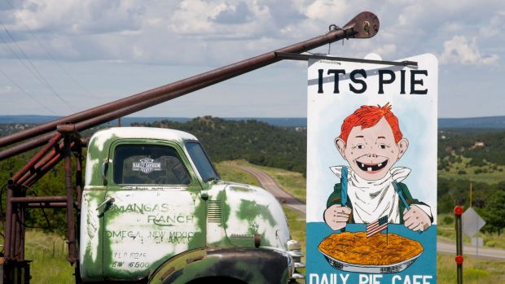*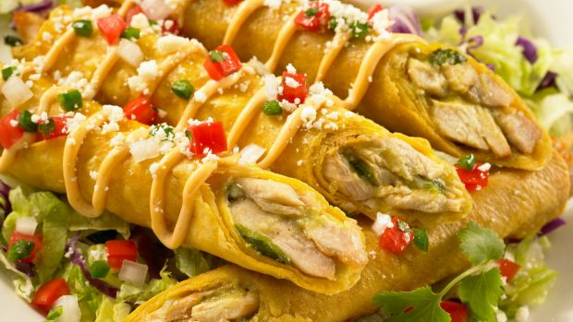

Match the titles with the image & text they refer to:

*Deep-dish Pizza - Hamburger – Texas Barbecue - Clam Chowder - Tacos - Apple pie – Thanksgiving – Hominy Grits - Drop Biscuits and Sausage Grav – Bagel & Lox*



The saying is "American as " for a reason: this sweet treat is a national institution. Forget anybody who will try to tell you pecan or key lime is better, because they are lying. The simple combination of sugar, buttery pastry and tart sliced apples produces a dessert so extraordinary people have devoted their entire lives to perfecting it. For a particularly excellent example, try the with added green chilies at the Pie-O-Neer, in Pie Town, New Mexico. Phone ahead and Kathy Knapp, the self-proclaimed "Pie Lady of Pie Town", will save you a slice.



Every single American will have a different idea about where to find the best …………………. in the country, ranging from fast food on the West Coast (In-N-Out Burger) to fine dining in New York (The Spotted Pig). But only one place is recognised by the Library of Congress as being the birthplace of : New Haven, Connecticut. The year was 1900 and the establishment was Louis' Lunch, run by one Louis Lassen. Today his great-grandson, Jeff Lassen, guides the ship, which still serves burgers made from five-meat blend and cooked in a century-old cast iron grill.



It is basically illegal to visit Boston without trying New England . The fragrant soup is sold everywhere, and it looks hideous, being white and lumpy. But one taste is all it takes to fall in love. Whoever decided to mix the quahog shellfish with tender potatoes, salted pork, heavy cream and herbs is a total genius. There are many ways to eat it, but you may as well go all out and get a bread bowl at the Atlantic Fish Co., where the chefs carve out a cavity in a fresh boule, pour in the heavenly juice, then put the top back on.



Trying to narrow New York down to a single representative cuisine is a fool's errand. A Nathan's hot dog? Pastrami from Katz's? A bad cup of diner coffee? Let's pay respects to the city's strong Jewish population and go with bagels and lox, a weekend staple on many Manhattan tables. Scientific studies have been conducted trying to work out why the New York bagel reigns supreme over all others; legend attributes it to the water. Whatever the cause, head to Russ and Daughters on the Lower East Side and tell them you want a selection of smoked fish, cream cheeses and, if you're feeling flash, caviar.



in Chicago looks and tastes different. The dish is deep, as the name suggests, meaning the crust rises high and allows for an artery-choking volume of cheese and tomato sauce. Unsurprisingly, they call it a "pie". It is not for the lighthearted and should only be attempted while wearing dark clothes or a large napkin. For a particularly authentic meal, pair the pie with sugary soda. You might like to do this at an Uno Pizzeria, which claims to have invented the Italian American hybrid dish in 1943.



A in America means, essentially, a flaky scone often made with lard and buttermilk. In places such as Montana, where people burn energy working on horse ranches, biscuits are eaten at breakfast smothered in a thick white gravy that is studded with bits of sausage. It certainly wakes you up in the morning. For a fun twist, try a musical version in Austin, Texas, where offers varies with names like "the Aretha Franklin" (maple bacon, colby jack cheese).



Australians might like to stoke up a barbie on the weekend, but Texans live and die by the practice. Mesquite smoked meats and tenderising rubs are common obsessions, and it is not uncommon to go to football games and find people have brought entire ranges to the parking lots that are worth upwards of five or even ten thousand dollars – a pastime called "tailgating". For excellent brisket, head to the Dallas Farmers Market, stand in line for a bit, then find a seat at Pecan Lodge. Also good are the pork links, pulled pork, beef ribs and collard greens. Basically everything.



Southern food seems to exist in its own universe, and an entire list could be written just focusing on things like chicken and waffles (yes, you read that correctly). So perhaps it's a good idea to just go with one of the basics: , which is essentially corn milled into a rough powder and then boiled up with butter or bacon grease. It sounds rough but it's actually sublime. For proof, try Blossom Restaurant in Charleston, South Carolina, which offers Geechie Boy grits with shrimp and andouille sausage. Pair it with brussels sprouts and sweetened ice tea.



Los Angeles is a city with a taqueria on every street corner, basically. With so many Spanish-speakers it's possible to find anything from greasy nachos on Venice Beach to exquisite Michoacan-style goat stews. For a good sampler, forget the chain stuff and try El Huarache Azteca, a tiny, no-fuss eatery in the neighbourhood of Highland Park, where menus run the full gamut from fajitas to mole verde and "flautas" – fried crisp taquitos stuffed with chicken. (Guacamole is a no-brainer.) Keep in mind that Mexican food and Tex-Mex are two very different things.



So " " isn't technically a food, but it's such a legendary date on the American culinary calendar (the fourth Thursday of each November), that it needs to be acknowledged. Officially, the holiday is about friends and family, but everybody knows it's really about turkey, cranberry sauce, pumpkin pie, green bean casserole and bellyaches. While the recipes, like most things on this list, seem custom-made to give you a heart-attack or diabetes, they're all delicious, and taken together create one of the most ridiculous and enjoyable feasts you could ever attend. Many restaurants offer a menu, for the most special option is always a friend's house, even if they burn the bird.

**SPEAKING ACTIVITY**

What are the American sports that you know?   
According to you, which does best represent America? Why?   
Do you practise some?

**LISTENING ACTIVITY**

*Sports in America[[1]](#footnote-1)*

Watch the video (0’59 → 4’09) and answer the questions.

1. **What are some of the most popular sports in America?**

1. **Americans and Europeans use the word *football* to refer to different sports. Explain.**
2. **What has become a real custom in America?**

1. **What’s the favourite sport of the person who speaks in the video? Since when has it been his favourite sport?**

1. **True or false? Correct the sentence when the statement is false.**
2. The person in the video was a fan of the San Francisco Padres’ baseball team.
3. The person in the video isn’t a big fan of baseball and therefore, he never goes to the baseball stadium to watch a game.
4. Basketball can be called “America’s great pastime”.
5. **Listen to the video excerpt and complete the gaps with the missing word.**

So, every baseball …………………… in the US kind of has these same …………………… and ……………………, and it reminds you of being amongst American people, and so, it’s what we would use to call... and maybe still today, ……………………………………. So, that’s definitely one of the big sports in the US still and... Unfortunately, …………………… is not a very big sport in the US. I think it’s …………………… a little bit ……………………, but amongst my friends and most of the people I know, very very few of them watch soccer …………………….

LITERATURE

Take the quiz = <https://www.quizony.com/american-literature/1.html>

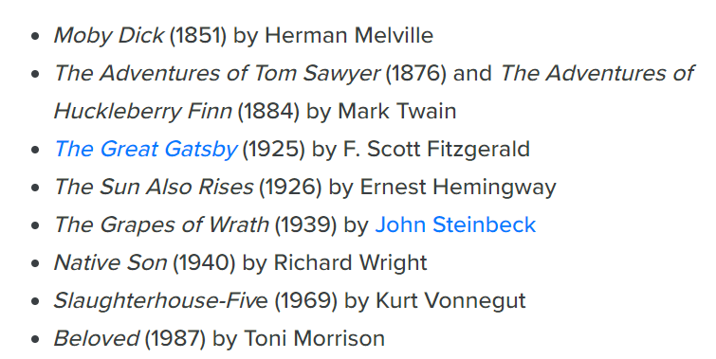

**SPEAKING PRACTICE**

What are the famous American authors that you know?

What are the famous American books that you know?

According to you, which book/author represents best the US?

What is your favourite genre? Why?

MUSIC

Try to discover the name of each singer/band. Give one of their most famous songs.

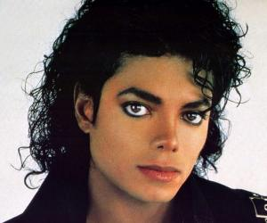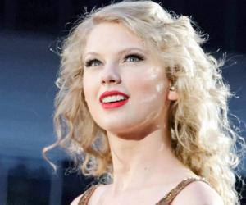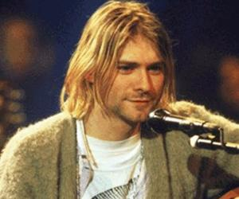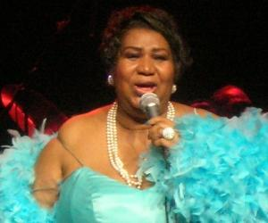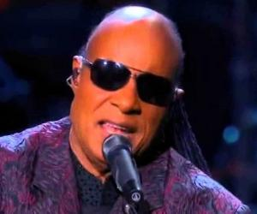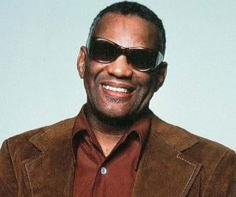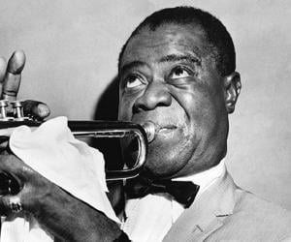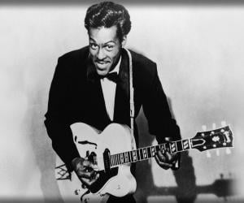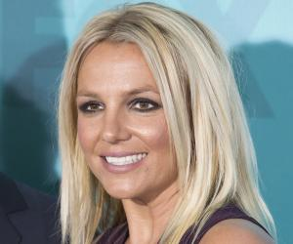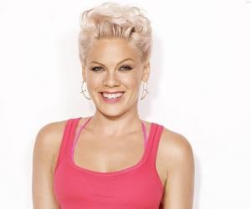

SYMBOLS

Explain each image. Why are they artefacts of the British culture? What do they symbolise?

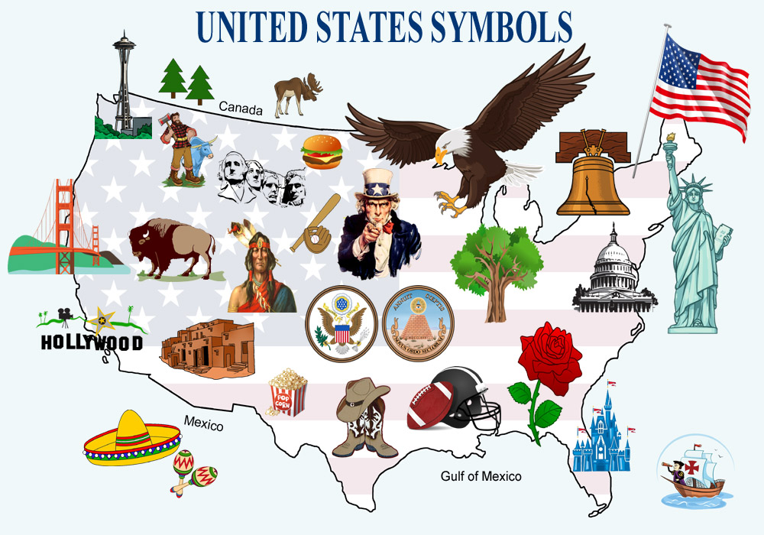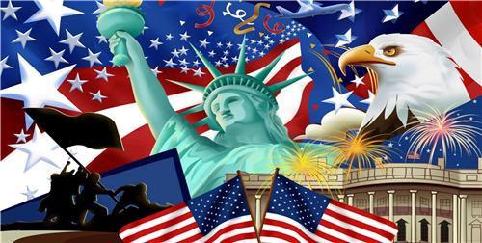

1. <https://www.youtube.com/watch?v=qsEqXG9m_cE> [↑](#footnote-ref-1)